1. **Agenda**:
   1. Let’s create a microservice acting as **“Service Discovery Agent”** using **Spring Cloud Netflix Eureka** which is available under Spring cloud Project.
2. 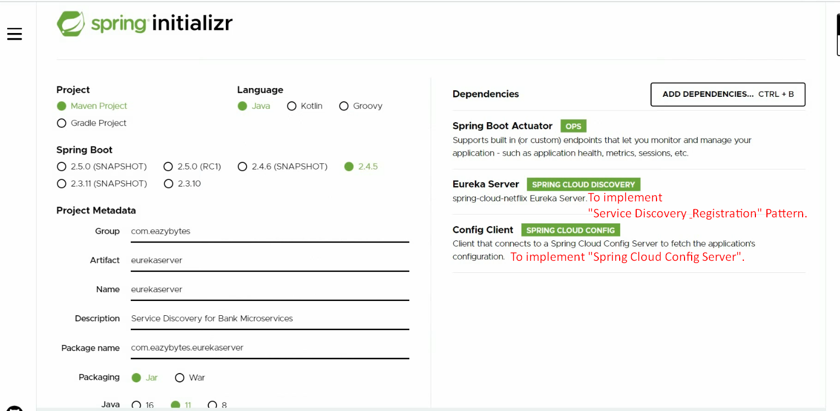
3. 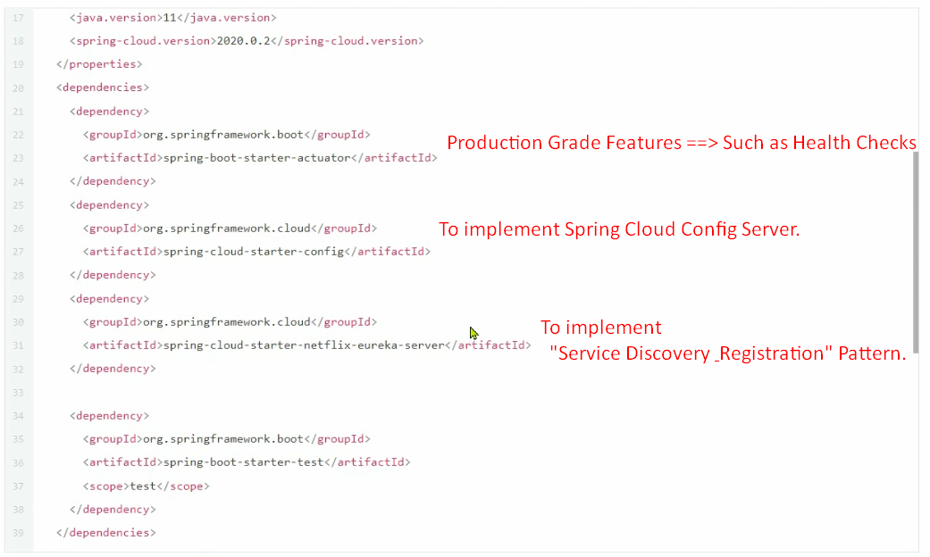
4. 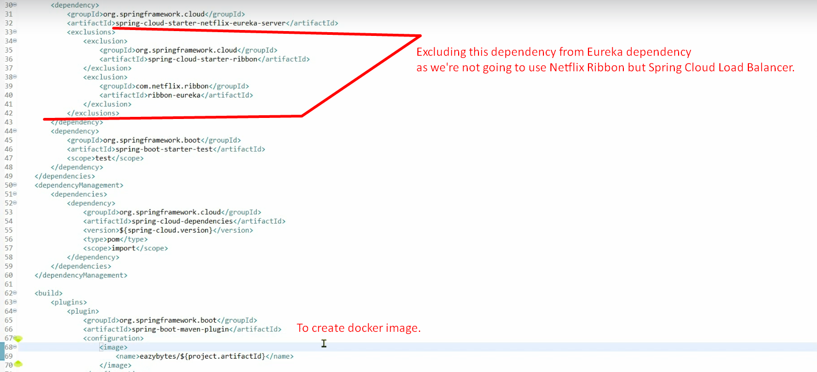
5. Steps: To create Eureka Server
   1. Add required dependencies as described above.
   2. @**EnableEurekaServer**:
      1. This will make your Spring Boot project/microservice acted as “Service Discovery & Registration”.
   3. 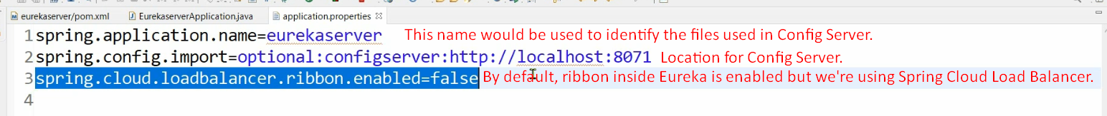
   4. 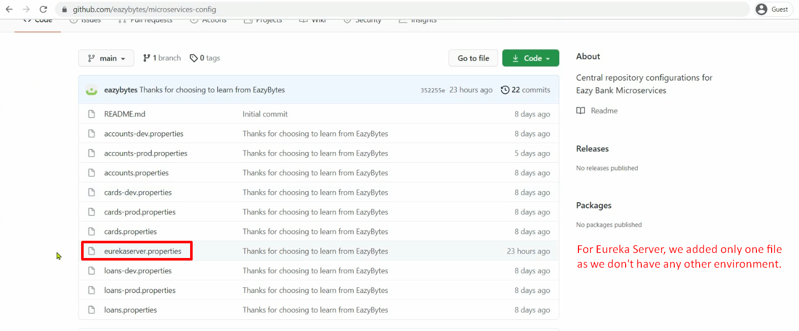
6. 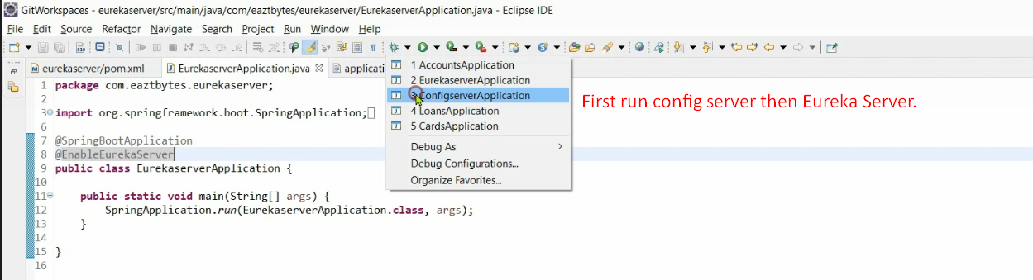
7. 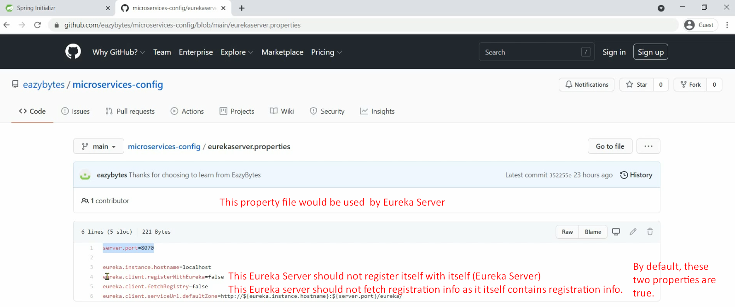
8. 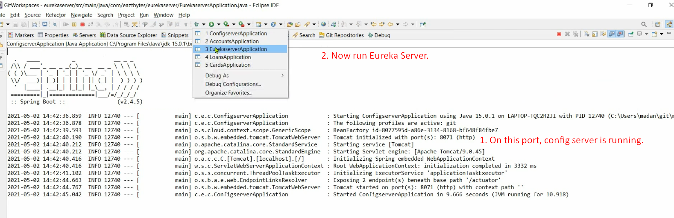
9. 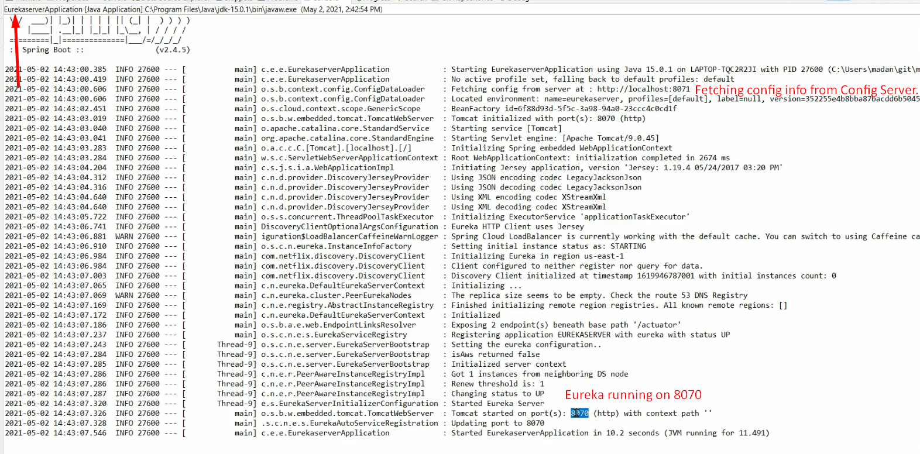
10. 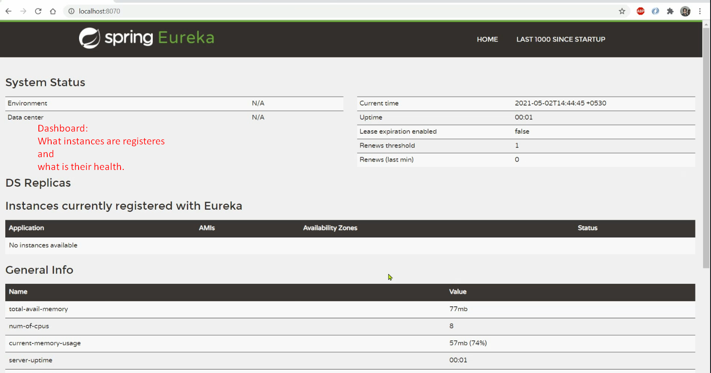
    1. What applications/instances are registered?
    2. What is the health of them?